**Name ___Yang Hu__________**

**Homework 1**

1. Courtney Leisner (MS Botany, 2009) designed an experiment to explore the growth of the plant *Bienertia Sinuspersici*, a species with C4 photosynthesis that is salt tolerant. Four levels of salt concentration were of interest to the researcher: 0, 50, 100 and 200 mM NaCl. The experiment consisted of 16 tubes identically planted with *Bienertia Sinuspersici* and then randomly assigned to the four salt treatments (4 replicate tubes per treatment). The tubes were placed in individual hydroponic growth systems at the specified concentration of NaCl in the water and the plants were allowed to grow for 8 weeks. At the end of the growth period, the plants were harvested and the dry weight of the roots was measured. The following table presents the data from this experiment:

|  |  |  |  |  |
| --- | --- | --- | --- | --- |
|  | NaCl Concentration (mM) | | | |
| Replicate | 0 | 50 | 100 | 200 |
| 1  2  3  4 | 2.4  10.6  12.0  4.6 | 40.9  47.7  31.9  36.3 | 70.5  96.7  26.4  76.0 | 127.2  134.0  28.1  78.3 |
| Mean | 7.4 | 39.2 | 67.4 | 91.9 |

**Show your work for each of following. All parts must be included**.

1. Construct, by hand, the entire ANOVA table for this analysis. Please refer to the example on page 409 of your textbook or the example on page 35 in the handout titled ‘Analysis of Variance for Completely Randomized One-Factor Design - Dr. Evans' Notes’. Also, conduct analysis of variance in R and SAS. Conduct hypothesis test using the traditional and p-value approach to hypothesis testing using α = 0.05. Perform multiple comparisons using Tukey’s procedure if necessary.





*Ho:*

*Ha:*  for at least one

= 0.05

*F = 6.308*

*Reject if*

*P value = P(F(0.01,df1,df2))=P(F(0.01,3,12))<0.01*

Conclusion: Reject Ho, there is sufficient evidence to conclude that the mean number of dry weights of roots

between the four salt treatments.

R results are shown below:

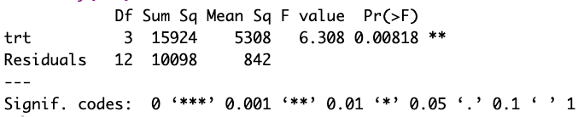

R result shows P = 0.008 < = 0.05, which indicates to reject the null hypothesis.

Tukey’s test is performed in R, the results are shown below. Tukey’s results show 95% family-wise confidence level of treatment 4 v.s. treatment 1 does not contain 0, which indicate the mean difference between these two groups will not be zero, so that these two groups’ mean value will not be equal. Tukey’s result aligns with the F test, which reject the null hypothesis, which is the mean value of the four groups are the same.

SAS results are shown below. The results agree with R results and manual calculation. P value is 0.0082 < 0.05, which indicate to reject the null hypothesis.

Tukey’s test from SAS is shown below. The results agree with R’s results, and for group wise comparison, SAS compared each group pair twice. The 0 salt group in SAS represents group 1 in R, and 200 salt group represents group 4 in R. SAS results show with 95% confidence interval, mean value of 0 salt group (R group 1) are significantly not equal to the mean value of 200 salt group (R group 4).

b) Assess the assumption of normality using normal probability plot of residuals and Shapiro Wilk’s normality test. Produce necessary output in R and SAS.

R results of normal probability plot of residuals and Shapiro Wilk’s normality test are shown below.

The residual normal probability plot indicate majority of the data are normally distributed. And the results of Shapiro Wilk’s normality test shows a p-value = 0.09 > =0.05, which indicate fail to reject the null hypothesis of Shapiro Wilk’s normality test, which means the data is likely normally distributed.

SAS results of normal probability plot of residuals and Shapiro Wilk’s normality test are shown below. The residual normal probability plot indicate majority of the data are normally distributed. And the results of Shapiro Wilk’s normality test shows a p-value = 0.0999 > =0.05, which indicate failed to reject the null hypothesis of Shapiro Wilk’s normality test, which means the data is likely normally distributed.

c) Assess the assumption of equal variances using plot of residuals vs. predicted values. Construct plot in R and SAS. Also, conduct hypothesis test for comparing variances using either the Brown and Forsythe test (SAS) or Levine’s test (R).

R plot of residuals vs. predicted values are shown below at left, and SAS plot of residuals vs. predicted values are shown at right.

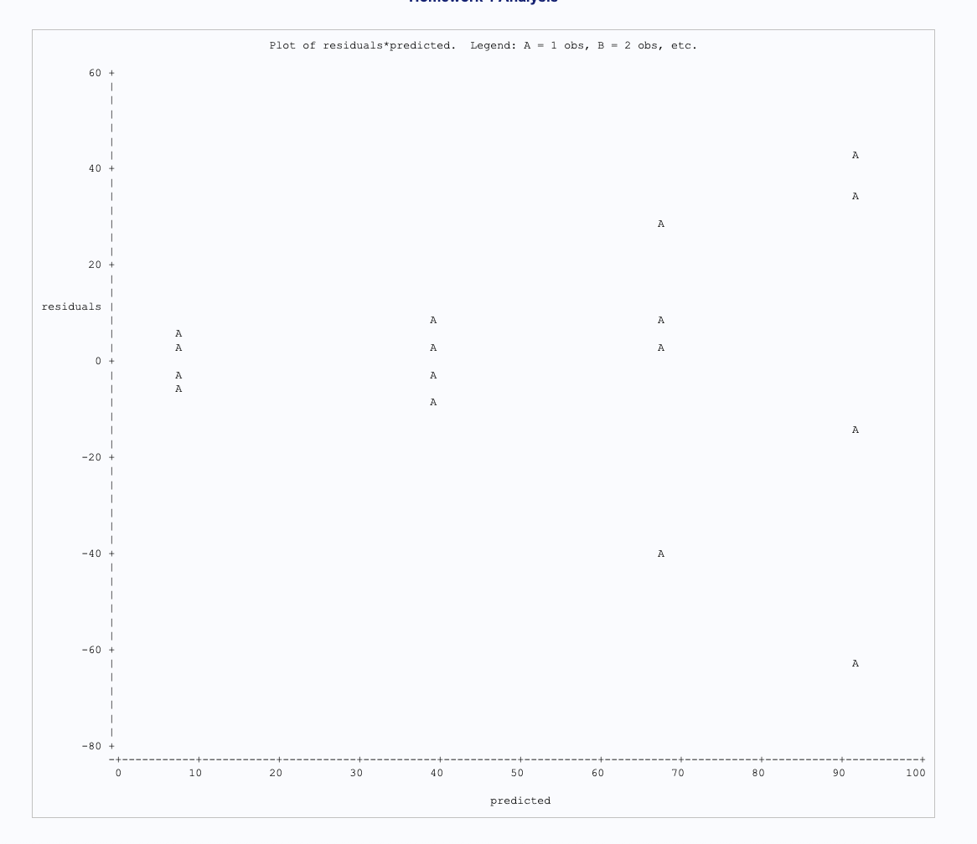

It can tell from the two plots, as the predicted value increase, the variance of residuals are also increased. With the thumb of rule, the range of residuals at the highest predicted value are about 100, and the range at the lowest predicted value is about 20. 100/20 = 5 > 3, which indicate the variance are not equal.

R results of Levenen’s test is shown below at left, and SAS results of the Brown and Forsythe test are shown on the right.

Both results show a similar p-value, 0.0335< =0.05. The result indicates to reject the null hypothesis of the tests. That is the variance are not equal. The conclusion also agrees with the thumbs of rule.

2. Suppose the United States Golf Association wants to compare the distances associated with four different brands of golf clubs when struck with a driver. Iron Byron, the USGA’s robotic golfer, is used to hit a random sample of ten balls of each brand in a random sequence. The distance is recorded for each hit, and the results are shown below.

|  |  |  |  |
| --- | --- | --- | --- |
| Brand A | Brand B | Brand C | Brand D |
| 251.2 | 263.2 | 269.7 | 251.6 |
| 245.1 | 262.9 | 263.2 | 248.6 |
| 248.0 | 265.0 | 277.5 | 249.4 |
| 251.1 | 254.5 | 267.4 | 242.0 |
| 265.5 | 264.3 | 270.5 | 246.5 |
| 250.0 | 257.0 | 265.5 | 251.3 |
| 253.9 | 262.8 | 270.7 | 262.8 |
| 244.6 | 264.4 | 272.9 | 249.0 |
| 254.6 | 260.9 | 275.6 | 247.1 |
| 248.8 | 255.9 | 266.5 | 245.9 |

1. Conduct analysis of variance in R and SAS. Conduct hypothesis test using the traditional and p-value approach to hypothesis testing using α = 0.05. Perform multiple comparisons using Tukey’s procedure if necessary.

*Ho:*

*Ha:*  for at least one

= 0.05

*F =*

*Reject if*

*P value = P(F(df1,df2))=P(F(0.001,3,12))<0.001*

R implement results are shown below:

R result shows P = 6.59e-11 < = 0.05, which indicates to reject the null hypothesis.

Tukey’s test is performed in R, the results are shown below. Tukey’s results show 95% family-wise confidence level of multiple group pairs do not contains, 0, such as 2-1,3-1,3-2, 4-2, and 4-3. That indicate the mean difference between these group pairs will not be zero, so that these two groups’ mean value will not be equal. Tukey’s result aligns with the F test, which reject the null hypothesis that the mean value of the four groups are the same.

SAS results are shown below. The results agree with R results and manual calculation. P value is <0.001, which indicate to reject the null hypothesis.

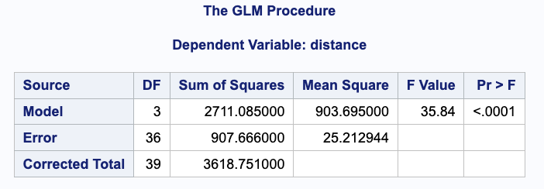

Tukey’s test from SAS is shown below. The results agree with R’s results, and for group wise comparison, SAS compared each group pair twice. Group a in SAS corresponding to 1 in R, and b is 2 in R, c is 3 in R and d is 4 in R. The results show group pairs 1-2,1-3,2-3,2-4 and 3-4 group mean values are significantly different with 95% confidence interval.

b) Assess the assumption of normality using normal probability plot of residuals and Shapiro Wilk’s normality test. Produce necessary output in R and SAS.

R results of normal probability plot of residuals and Shapiro Wilk’s normality test are shown below.

The residual normal probability plot indicates some portion of the data are aligned with the threshold line. And the results of Shapiro Wilk’s normality test shows a p-value = 0.013 < =0.05, which indicate to reject the null hypothesis of Shapiro Wilk’s normality test, which means the data is unlikely normally distributed.

SAS results of normal probability plot of residuals and Shapiro Wilk’s normality test are shown below. The residual normal probability plot indicate some portion of the data are aligned with the threshold line. And the results of Shapiro Wilk’s normality test shows a p-value = 0.013< =0.05, which indicate to reject the null hypothesis of Shapiro Wilk’s normality test, which means the data is unlikely normally distributed.

c) Assess the assumption of equal variances using plot of residuals vs. predicted values. Construct plot in R and SAS. Also, conduct hypothesis test for comparing variances using either the Brown and Forsythe test or Levine’s test.

R plot of residuals vs. predicted values are shown below at left, and SAS plot of residuals vs. predicted values are shown at right.

It can tell from the two plots, as the predicted value increase, the variance of residuals does not change very much, the red line keeps almost same level. That indicate equal variances between the golf groups.

R results of Levenen’s test is shown below at left, and SAS results of the Brown and Forsythe test are shown on the right.

Both results show a similar p-value, 0.9235> =0.05. The result indicates fail to reject the null hypothesis of the tests. That is the variance are equal among the golf brand groups. The conclusion also agrees with the thumbs of rule.